Boyd Poblete
Cauayan City, Isabela
09354451531
boydpoblete@gmail.com

1/18/2023

Olan Hodges
Ensign College

EXECUTIVE SUMMARY

Introduction
A high-level proposal listing of the necessary network equipment to build out a network infrastructure for the new building and includes the major switching and router equipment and any necessary media converters.
The Product
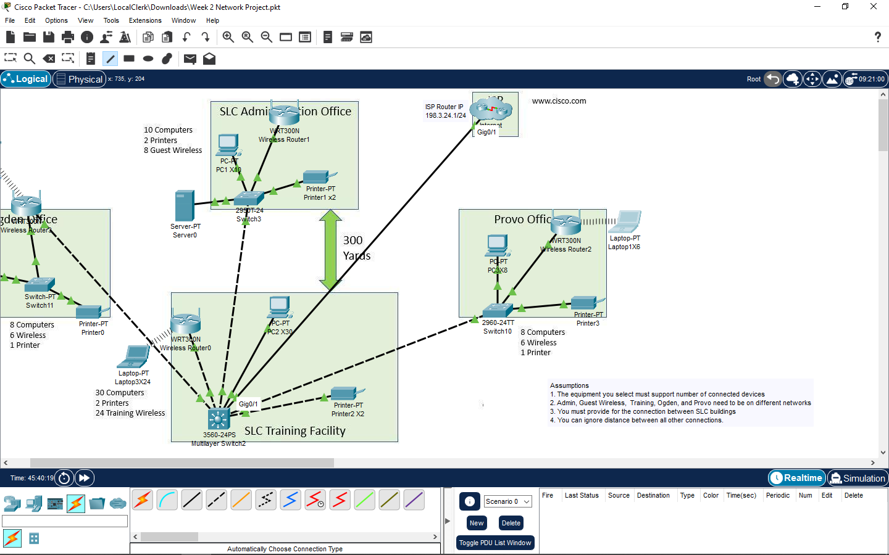
- 56 Computers
- 36 laptops
- 6 Printers
- 4 routers
- 4 switches
- 1 server

Analysis Findings

I analyzed the network topology given in the diagram. From there I installed the exact numbers of computers, printers, routers and switches in different offices. I made sure that I used the correct wires for the routers and switches. I then had to connect the laptops in to the routers. It took me some time to figure out how to connect those wireless connections and to figure out how to use the packet tracer. I had to ask for help from my classmates and watch Youtube tutorials in order to use the packet tracer.

